FraudShield — Insurance Fraud Detection System
Project Documentation | Epic 7: Project Demonstration & Documentation

1. Introduction
Insurance fraud is one of the most serious problems faced by the insurance industry. When a claimant intentionally provides false or exaggerated information to receive a payout they are not entitled to, the financial burden ultimately falls on honest policyholders through higher premiums.
Traditional fraud detection relies on manual review by claims investigators. This process is slow, expensive, inconsistent, and cannot scale with the growing volume of insurance claims. FraudShield is a machine learning based system that trains six classification algorithms on historical auto insurance claim data, identifies the best performing model, and deploys it as an interactive web application. Investigators can enter claim details through a simple form and receive an instant fraud prediction along with a confidence score.

2. Problem Statement
Given a set of attributes about an auto insurance claim, can we automatically predict whether the claim is fraudulent or legitimate? This is a binary classification problem where the target variable is fraud_reported with values Y (fraud) and N (legitimate).
The insuranceFraud_Dataset contains 1,000 claims of which 247 (24.7%) are fraudulent. This class imbalance makes accurate fraud detection more challenging than simply predicting the majority class.

Challenges
- Class imbalance — 24.7% fraud vs 75.3% legitimate claims
- Missing values present as '?' in several columns requiring imputation
- Mix of numeric and categorical features requiring different preprocessing steps
- Need for a model that is accurate and interpretable for investigator trust

3. Dataset Description
The insuranceFraud_Dataset.csv was used for this project. It contains auto insurance claims with a mix of policyholder information, incident details, and claim amounts.

Attribute | Value
Dataset Name | insuranceFraud_Dataset.csv
Total Records | 1,000 claims
Total Features | 39 columns
Features Used After Preprocessing | 33 features
Fraudulent Claims (Y) | 247 (24.7%)
Legitimate Claims (N) | 753 (75.3%)
Missing Values | Present as '?' — imputed with median/mode
Train Set | 800 records (80%)
Test Set | 200 records (20%)

Feature Categories
- Policy Info — months_as_customer, policy_state, policy_csl, policy_deductable, policy_annual_premium, umbrella_limit
- Insured Person — insured_sex, insured_education_level, insured_occupation, insured_hobbies, insured_relationship
- Incident Details — incident_type, collision_type, incident_severity, authorities_contacted, incident_hour_of_the_day
- Claim Details — total_claim_amount, injury_claim, property_claim, vehicle_claim, witnesses, police_report_available
- Vehicle Info — auto_make, auto_model, auto_year

4. Methodology

4.1 Data Preprocessing
- Dropped irrelevant columns: policy_number, policy_bind_date, insured_zip, incident_date, incident_location
- Replaced '?' values with NaN throughout the dataset
- Dropped columns where more than 40% of values were missing
- Imputed remaining missing values: median for numeric columns, mode for categorical columns
- Applied Label Encoding to all categorical features using scikit-learn LabelEncoder
- Applied StandardScaler to normalize all 33 features to zero mean and unit variance
- Split data into 80% training and 20% test using stratified sampling to preserve the 24.7% fraud ratio

4.2 Exploratory Data Analysis
- Target variable is imbalanced — 75.3% legitimate vs 24.7% fraud
- Claims with no police report filed show significantly higher fraud rates
- High total claim amounts relative to deductible are associated with fraud
- Certain incident types (Single Vehicle Collision) show higher fraud proportions
- Correlation analysis reveals total_claim_amount and sub-claims are highly correlated

5. Model Development
Six classification algorithms were trained on the preprocessed training set and evaluated on the held-out test set. All models used random_state=42 where applicable.

Model | Key Parameters
Decision Tree | max_depth=5, random_state=42
Random Forest | n_estimators=100, max_depth=8, random_state=42
K-Nearest Neighbors | n_neighbors=7
Logistic Regression | max_iter=500, random_state=42
Naive Bayes | GaussianNB — default parameters
Support Vector Machine | kernel=rbf, probability=True, random_state=42

Model Saving
- best_model.pkl — trained Decision Tree classifier
- scaler.pkl — fitted StandardScaler
- label_encoders.pkl — dictionary of fitted LabelEncoders per feature
- feature_names.pkl — ordered list of 33 feature names
- model_results.pkl — accuracy scores for all 6 models

6. Results and Evaluation

6.1 Model Accuracy Comparison
Model | Test Accuracy | Rank
Decision Tree | 81.00% | 1st — Best
Random Forest | 79.00% | 2nd
Logistic Regression | 79.00% | 2nd
K-Nearest Neighbors | 74.50% | 4th
Support Vector Machine | 74.50% | 4th
Naive Bayes | 70.50% | 6th — Worst

6.2 Key Observations
- Decision Tree with max_depth=5 achieves the highest accuracy of 81% and was selected for deployment
- Random Forest and Logistic Regression both achieve 79%, close to but not matching the Decision Tree
- Naive Bayes performs worst at 70.5% due to its feature independence assumption being violated
- The gap between best and worst model is 10.5 percentage points
- Decision Tree was selected for deployment because it is the most accurate and fully interpretable

6.3 Key Fraud Predictors
- police_report_available = NO — strongest indicator of fraudulent behavior
- witnesses = 0 — no witnesses significantly increases fraud probability
- total_claim_amount — high claims relative to policy deductible
- incident_hour_of_the_day — unusual hours with no supporting evidence
- incident_type — Single Vehicle Collision has higher fraud proportion

6.4 Web Application Screenshots
The trained model was deployed as a Flask web application with four pages: Home, Predict, Analysis, and About.

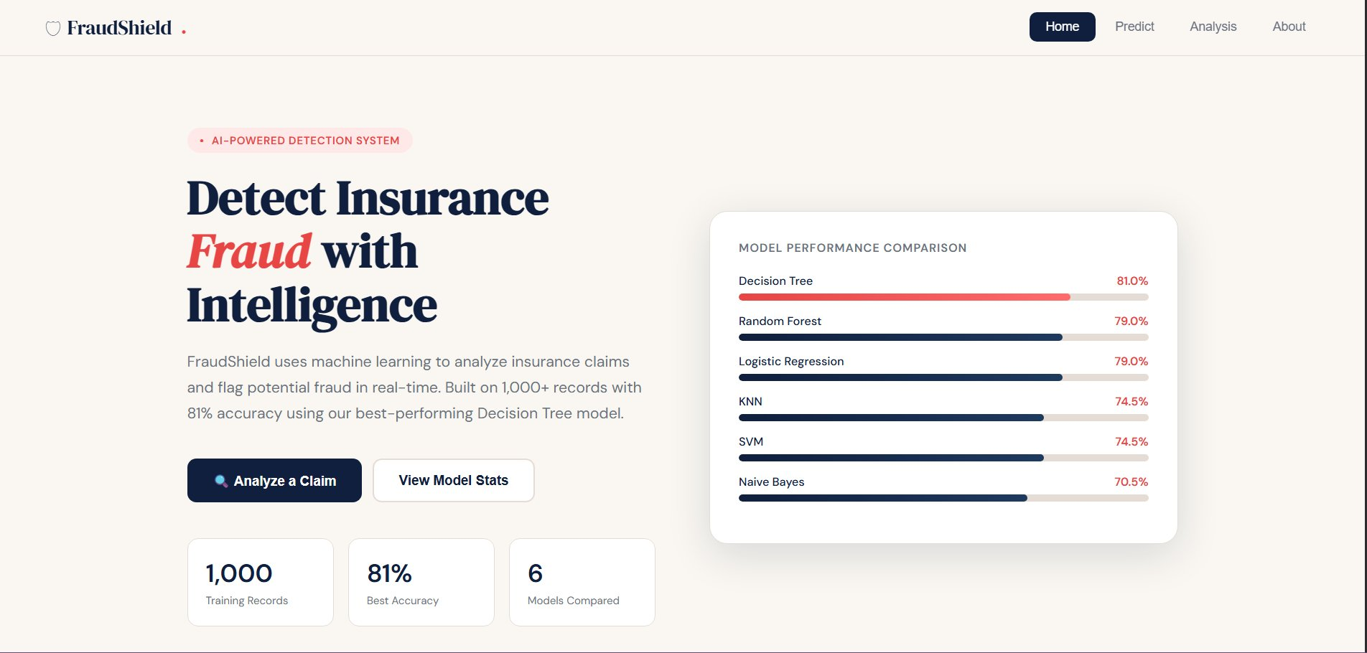
Figure 1: Home Page — Project overview with model performance comparison bars

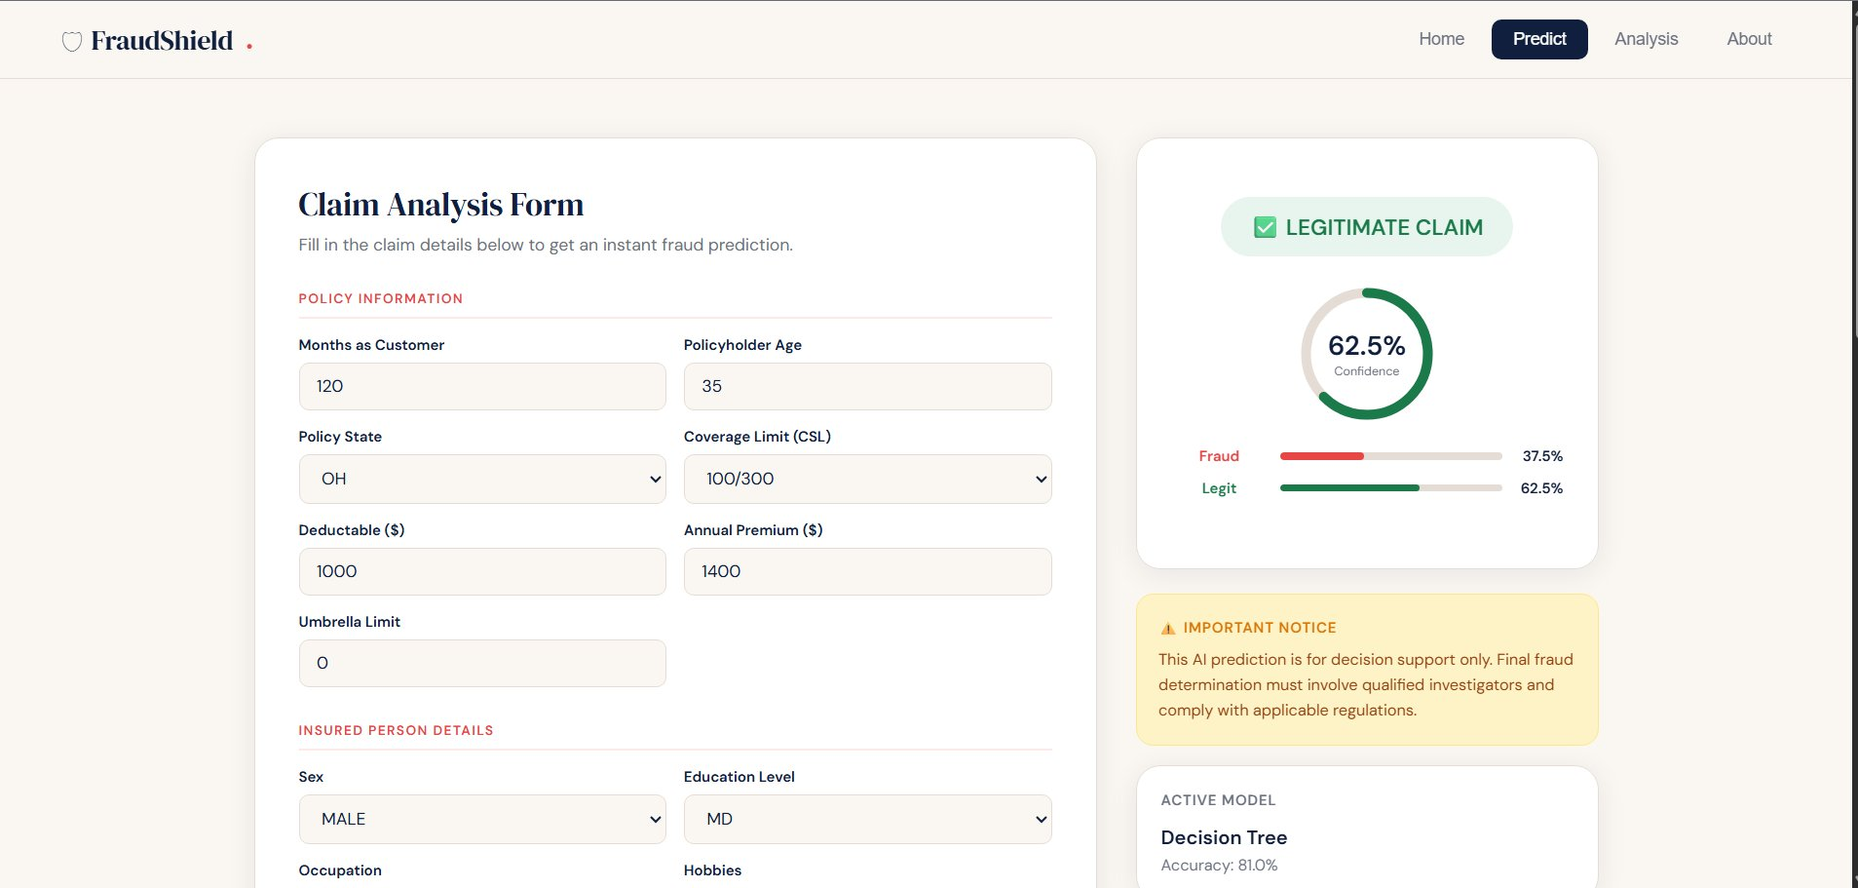
Figure 2: Predict Page — Claim input form with real-time fraud prediction result

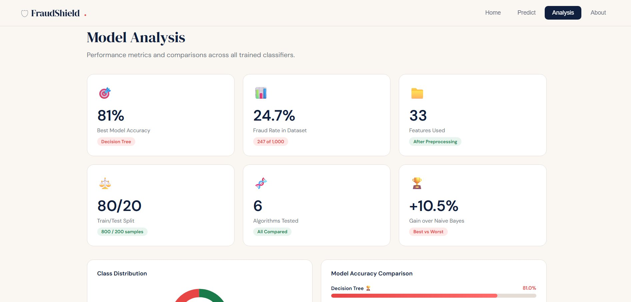
Figure 3: Analysis Page — Model performance KPI cards and accuracy comparison

7. Conclusion and Future Work

7.1 Conclusion
FraudShield successfully demonstrates a complete end-to-end machine learning pipeline for insurance fraud detection. The project covers all stages from data collection and preprocessing through exploratory analysis, model training, evaluation, and web deployment.
The Decision Tree classifier with max_depth=5 achieves 81% test accuracy on the insuranceFraud_Dataset, making it the best performer among the six algorithms evaluated. The interactive web application allows investigators to enter claim details and receive instant predictions without any programming knowledge. The system is designed as a decision support tool — all flagged claims are reviewed by a human investigator before any action is taken.

7.2 Future Work
- Apply SMOTE oversampling to better handle the 24.7% class imbalance and improve fraud recall
- Use hyperparameter tuning (GridSearchCV) to further improve model accuracy beyond 81%
- Explore ensemble methods like XGBoost or LightGBM for potentially higher accuracy
- Integrate with a live claims database for real-time scoring of incoming claims
- Add a feedback loop so investigators can correct wrong predictions to retrain the model
- Deploy on a production server using Gunicorn instead of Flask's development server

References
1. insuranceFraud_Dataset.csv — Auto Insurance Fraud Dataset used for model training.
2. Ngai, E.W.T. et al. (2011). The application of data mining techniques in financial fraud detection. Decision Support Systems, 50(3), 559-569.
3. Artis, M. et al. (2002). Detection of automobile insurance fraud with discrete choice models and misclassified claims. Journal of Risk and Insurance, 69(3), 325-340.
4. Pedregosa, F. et al. (2011). Scikit-learn: Machine Learning in Python. Journal of Machine Learning Research, 12, 2825-2830.
5. Flask Documentation. Pallets Projects. https://flask.palletsprojects.com

